Suffix tree

Description

The suffix tree is basically a suffix trie with compression. It is good for the reader to read first the document about the suffix trie in order to understand this article.

From the Suffix trie article we can see how the structure looks:
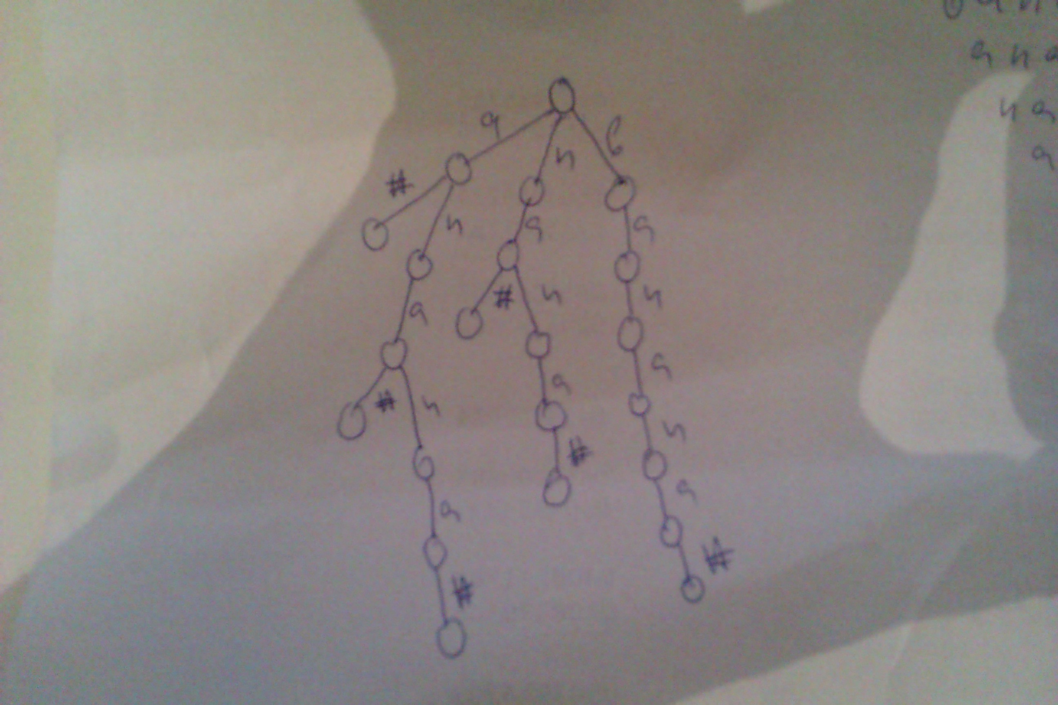

However, some of the nodes and the edges may not be needed.
The compressed trie looks like:
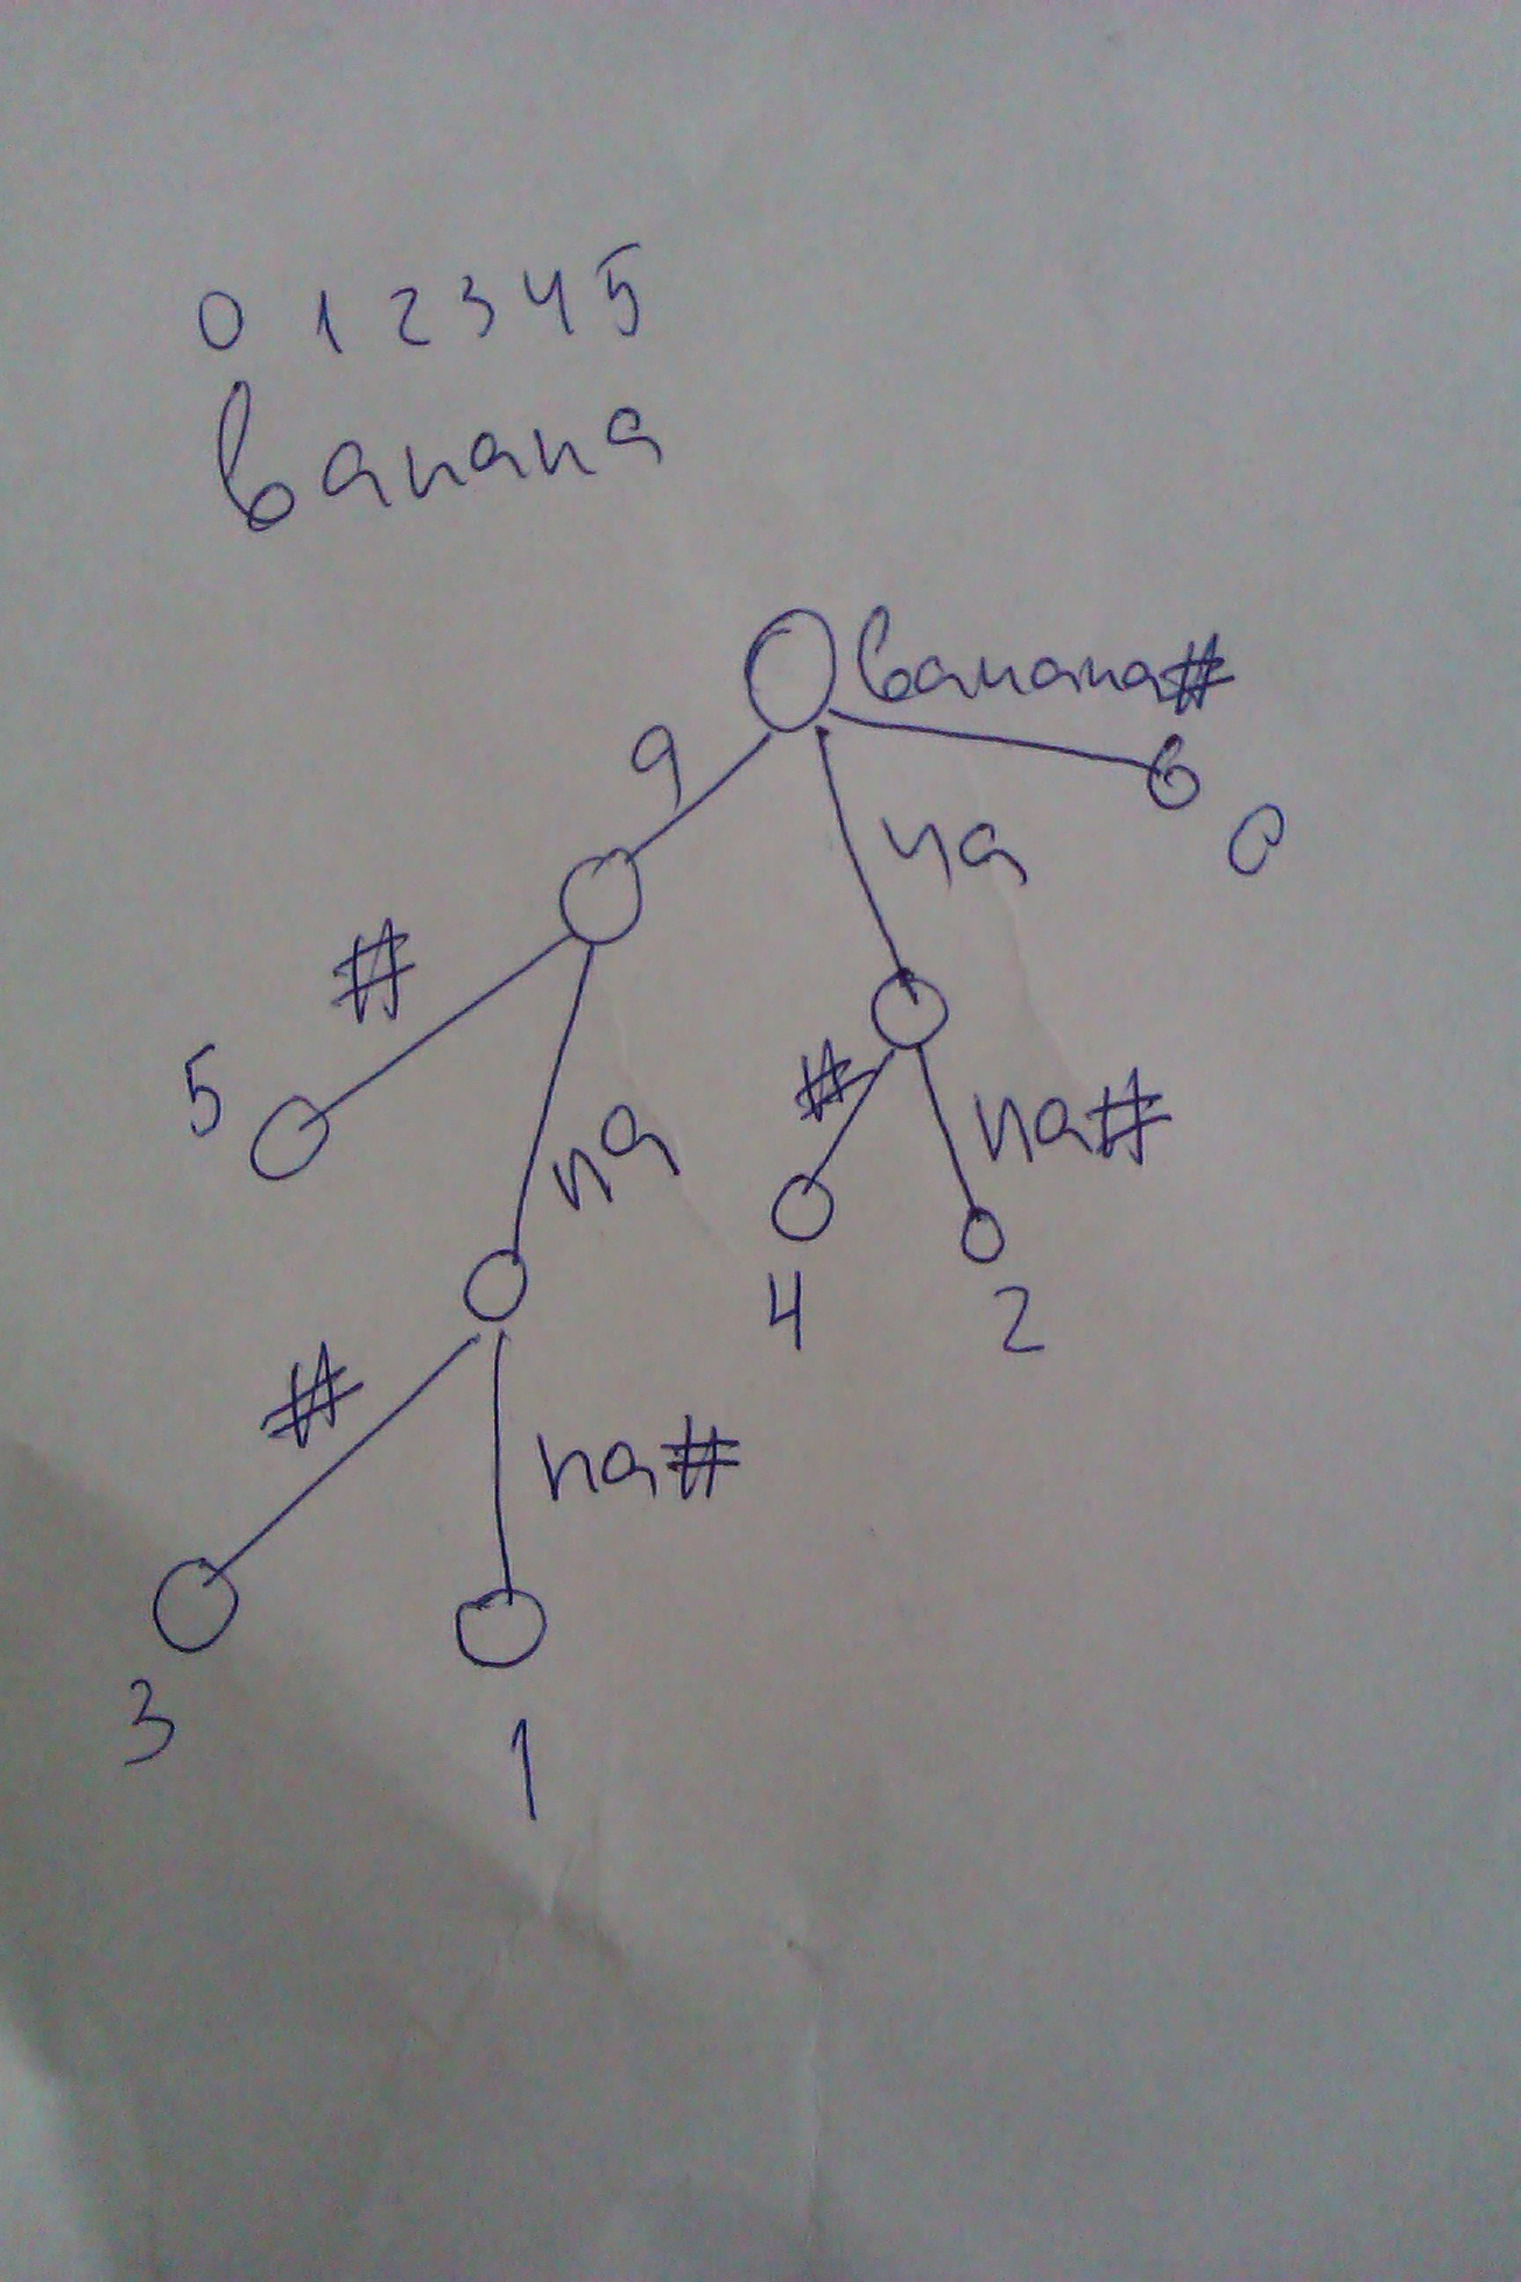

In fact we do not have to keep the substrings themselves but rather just the starting index and the ending index of the substring.
This would lead to O(N) space which is an improvement to the O(N^2) time of the Suffix trie.

Building the Suffix tree
The standard way to build it is to work on every suffix and add it the tree. Unlike the Suffix trie here we would have to split edges when we needed. For example if we have stored already an edge anana, but we want to store later a substring anapaka, then we would have to split the initial edge anana after the prefix ana.

There is also a faster way to build a suffix tree. It was introduced by Ukkonen (professor at Uni of Helsinki) in 1995. The algorithm is untraditional to this problem in a sense that rather approaching the problem by generated every suffix directly, it starts with the prefices, adding characters to generate the suffices.

Searching in the Suffix tree
You can search by just traversing the tree. Note that in order to find the index you would always have to visit a leaf node where the starting index is stored.
The time needed for search is O(|P| + k) where |P| is the length of the pattern (needle) and k is the number of occurrences of that pattern in the text.

Comparison to Suffix Trie
The suffix trie takes more space and also searching in it is a bit slower since we have more nodes to consider (more pointers to visit, etc). Generally, the suffix trie is inefficient for strings bigger than 1000 characters. The suffix tree is good for strings even with 10^6 characters meaning that we can build the tree in less than a second.
However, Ukkonen's improvement comes at the cost that the implementation is harder.

Comparison to Suffx Array
Both take the same space though the suffix array takes less by a constant factor. However, building the Suffix Array takes O(N * log(N) * log(N)) time normally. We can very easily transform a suffix tree to a suffix array by traversing the tree in-order meaning that we can build a suffix array in O(N) time.
Searching in the Suffix array can be done in O(|P| * logN) time or O(|P| + logN) with improvement. This is slower than searching in the suffix tree.
The reason why the suffix array is popular and at times better than the suffix tree is that it is easy to implement and it takes less space. The suffix array is popular at programming competitions since the standard O(N * log(N) * log(N)) implementation can be done in less than 50 lines of code.

